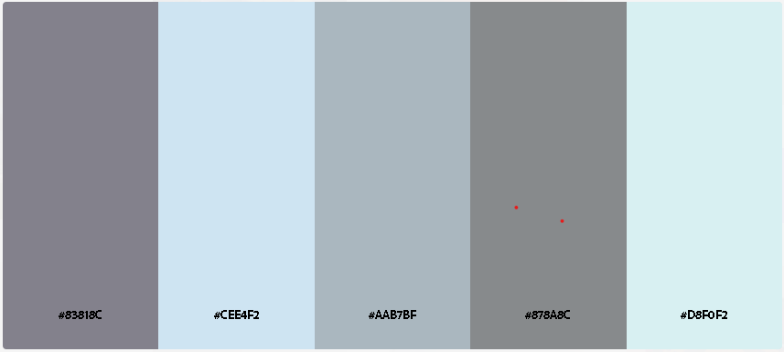

#83818C #CEE4F2 #AAB7BF #878A8C #D8F0F2

<link rel="preconnect" href="https://fonts.googleapis.com">
<link rel="preconnect" href="https://fonts.gstatic.com" crossorigin>
<link href="https://fonts.googleapis.com/css2?family=PT+Serif:ital,wght@0,400;0,700;1,400;1,700&display=swap" rel="stylesheet">

